**A REPORT** **ON**



**STOCK VISUALIZER**

**UNDER**

**NON-SYLLABUS PROJECT**

**Submitted To: Submitted By:**

**Mrs. Sikha Guatam Garvesh Jangid (PIET21CS063`)**

**Assistant Professor Faizan Bhati(PIET21CS062)**

DEPARTMENT OF ARTIFICIAL INTELLIGENCE & DATA SCIENCE POORNIMA INSTITUTE OF ENGINEERING AND TECHNOLOGY, JAIPUR

(Academic Year 2022-23) (Odd)

**DECLARATION**

I hereby declare that the Non syllabus Project report entitled “**STOCK VISUALIZER**" was carried out and written by me under the guidance of **Mrs. Sikha Gautam**, Assistant Professor, Department of Computer Engineering, Poornima Institute of Engineering & Technology, Jaipur. This work has not been previously formed the basis for the award of any degree or diploma or certificate nor has been submitted elsewhere for the award of any degree or diploma.

Place: Jaipur Garvesh Jangid

Date: 19/9/2022 PIET21CS063

**Table of Contents**

|  |  |  |
| --- | --- | --- |
| **S. No.** | **Description** | **Page Number** |
| 1. | Title | I,II |
| 2. | Declaration | III |
| 3. | Table of Contents | IV |
| **4.** | **Chapter 1: Introduction of Project** | 1 |
| 5. | 1.1 Objective of Project | 1 |
| 6. | 1.2 Types of users | 2 |
| 7. | * 1. Constraints   2. Dependency | 3  3 |
| 8. | 1.5 Methodology Used or Project Life cycle  **(Waterfall Model)** | 3-4 |
| **9.** | **Chapter 2: Requirement Analysis** | 5 |
| 10. | 2.1 Functional Requirement | 6 |
| 11. | 2.2 Non-functional Requirement | 7 |
| 12. | 2.3 Technology Used | 7 |
| 13. | 2.4 H/w Configuration | 8 |
| 14. | 2.5 Advantages | 8 |
| 15. | 2.6 Disadvantages | 8 |
| 16. | 2.7 Applications | 8 |
| 17. | 2.8 Product Perspective | 8 |
| 18. | **Chapter3:Design** | 9 |
| 19. | 3. 1 Data flow Diagram | 9-10 |
| 20. | 3.2 UML | 11 |
| 21. | 3.3 Class Diagram | 11-12 |
| 22. | 3.4 Object Diagram | 12 |
| 23. | 3.5 Sequence Diagram | 13 |

|  |  |  |
| --- | --- | --- |
| 24. | 3.6 Communication Diagram | 14 |
| 25. | 3.7 Activity Diagram | 14-15 |
| 26. | 3.8 State Chart Diagram | 15-16 |
| 27. | 3.9 Deployment Diagram | 16-17 |
| 28. | 3.10 Component Diagram | 17-18 |
| 29. | **Chapter-4 Conclusion & References** | 19 |
| 30. | 4.1 Conclusion | 19 |
| 31. | 4.2 References | 19 |
| 32. | **Chapter-5 Snapshots** | 21-22 |
| 33. | **Chapter -6 Code** | 23-24 |

**List of Figures**

|  |  |  |
| --- | --- | --- |
| S. No. | Figures | Page No. |
| 1. | Zero Level DFD | 9 |
| 2. | First Level DFD | 10 |
| 3. | Use Case Diagram | 11 |
| 4. | Class Diagram | 12 |
| 5. | Sequence Diagram | 13 |
| 6. | Activity Diagram | 15 |
| 7. | State Chart Diagram | 16 |
| 8. | Deployment Diagram | 17 |
| 9. | Component Diagram | 18 |

**Chapter -1 Introduction to Project**

Indian Shares listed in National Stock Exchange and Bombay Stock Exchange is closely monitored by the prospective investors and business analysts after the end of every trading session for the assessment of best performing stocks.  
  
Project report on Stock Market contains the technical assessment method that is completely statistical and entails no personal views or prejudiced data of any kind. Indian Stock Market project Report is released after the end of every trading session and for a comprehensive performance analysis the firms release yearly or bi-annual project reports.  
  
From easy to understand and assess stock market project reports the users can keep a check on how well a stock has performed over a certain period of time and can compare it with the index of another competitive stock. The performance ranking in the reports allows the users to monitor the top performing NSE and BSE shares at a quick look.

# Objective of Project:

The Stock exchange is the index of the economy of a country. It is the center of the capital market. It is called the economic mirror of a country. It is called share market interchangeably. In developing trade, commerce and industries in a country stock exchange play an important role. The objectives of establishing a stock exchange are mentioned below:

* **To supply Capital**

The main function of a stock exchange is to help companies elevate money. It is established to supply the required capital for companies of a country. To achieve this task, ownership in a private corporation is sold to the public in the form of shares of stock. Funds received from the sale of stock contribute to the firm’s capital formation.

* **To inspire savings**

This inspires people to save their income by making a profit. A stock exchange helps in determining the prices for various securities. Continuous purchase and sale of securities on a stock exchange lead to the evaluation of their prices. Regular dealings reduce wide fluctuations in prices. It accumulates the individual income and yet they go to the industries to the economic development of a country.

* **To trade financial instruments**

It is established to trade the financial instruments for individual investment and company collect capital. It provides a regular meeting place where people can convert their money into securities and securities into money. Buying and selling of securities are confined to one particular place and the investors are saved the trouble of going to different places to buy or sell securities.

* **To develop economy**

It helps economic development by supplying the capital to the industries. Unregulated markets can have an unenthusiastic impact on capital formation. Close regulation of stock exchanges allows strangers from all parts of the world to honour contracts executed in the daily trading of shares. It is an important objective of the stock exchange.

* **To present information**

Another objective of the stock exchange is to present information about transactions and financial conditions of the companies. It reflects changes taking place in the country’s economy. Price trends on stock exchange indicate trade cycles i.e. boom, recession, depression, recovery, etc.

* **To do long-term financing**

Commercial banks generally disburse the short-term loan. So, supplying long-term finance is an objective of the stock exchange. Any company which wants to get its securities listed has to submit to these rules and regulations.

* **To raise awareness**

It raises awareness among the general people by giving information than to invest and gain profit from the market. Thus, stock exchanges exercise a healthy influence on the working and management of companies.

* **To have a fair operation**

To transact the financial instruments easily and fairly stock exchange is established. A stock exchange channelizes the investible funds in more productive industries. A company with better performance and prospects has no difficulty in raising its capital. So, it is a duty of stock exchange to secure both investors and borrower.

* **To protect fraudulently**

It is also to ensure that no fraudulence occurs in a transaction. A stock exchange functions exactingly according to established rules and regulations. These rules and regulations provide a check on overtrading in securities and manipulation of prices. The Government, too; exercises supervision and control over a stock exchange. By this means the evils can deceit the tender investors and the stock are liable for protecting that.

* **Convenience**

The objective of the stock exchange is to formulate policies for easy transactions and the safety of the investors and companies. A stock exchange informs investors which way the investment wind is blowing. By directing the flow of capital into worthwhile projects, it gives an impetus to the economic development of the country.

* **Security and Transparency**

The lawful sale of stock on any exchange requires dependable and correct information. By requiring a high level of transparency from all trading companies, the stock exchange creates a more protected environment for investors, which helps them to verify the risks of investing.

So, the objectives of the stock exchange are great and efficient operations of stock exchange are so much required for the economic development of a country.

# Types of Users:

**Login Activity:**

Another important part of User Management is being able to monitor the login activity. The system should be able to show the different users that have logged in to which module and at what time and from which IP Address. Access as per IP address is essential for Users to buy and sell the stocks from website .

**ii User Characteristics:**

There are 2 user Levels in our Stock Visualizer:

1. Admin
2. Customers/Viewers
3. **Admin**: Admin is main developer of the webserver , who input and feed the data in main function code . Any change which happen in website is all done by the admin. Admin has all the access of all user info and company info. Any changes even the slightest changes is done by Admin manually.
4. **Customer**: Customer are vital part of the system. Customer have access to view the stock price of every company as well as previous history of company too. Customer should at least be capable to use the web UI interface.

# Constraints:

1. **Memory**: System will have only 10GB space of data server.
2. **Language Requirement**: Software must be only in English.
3. **Budget Constraint**: Due to limited budget, HMS is intended to very simple and just for basic functionalities. UI is going to be very simple.
4. **Implementation Constraint**: Application should be based on Java only.
5. **Reliability Requirements**: System should sync frequently to backup server in order to avoid the data loss during failure, so it can be recovered.

# Assumption and Dependencies:

It is assumed that system developed will work perfectly that is going to be developed under the Windows OS, and Apache Server with Mongo DB database. If incase of any difficulties, SRS should be flexible enough to change accordingly.

# Methodology:

The method being used in developing the system is the system Development Life Cycle (SDLC) The SDLC process includes project identification and selection, project initiation and planning, analysis, design, implementation and maintenance.

**Waterfall Model (SDLC):**

**. System Development Life Cycle (SDLC):**The system Development Life Cycle (SDLC) is a traditional methodology used to develop, maintain and replace or enhance information system. The main reason SDLC model is chosen because in SDLC it is possible to complete some activities in one phase in parallel with some activities of another phase. The life cycle can also be interactive that is phase are repeated as required until an acceptable system is found.

**Phase 1: Project identification and selection**

In this phase the project information system needs are identified and analyzed such as identified the title of the project that is Web Based XpathAnalyzer, scope and objective of the Web Based XpathAnalyzer.

**Phase 2: Project initiation and planning**

During this phase the Gantt chart has been developed as a time line to determining the task involve in

developing the Web Based XpathAnalyzer.

**Phase 3: Analysis**

In the phase, the exiting system is studies by collecting the information through the Internet and analyzed the information to get alternatives for the used of proposed system. Determine what the Web Based XpathAnalyzer should do.

**Phase 4: Design**

Logical design is the fourth phase in SDLC methodology. The functional features chosen for the proposed system in Analysis phase are described. Part of the logical design of the information system is to devise the user interface. The interface plays an important role to connect the user with the system and is thus extremely important

**Chapter -2 Requirement Analysis**

# Functional Requirement:

1. **USER INTERFACE : -**

* record the viewers sign in and sign up
* record the viewer activity
* record the number of occupants
* record the customer activity
* display the sensex
* record the customer’s phone number
* display whether or not the stocks is eligible to buy or not
* generate a unique confirmation number for each
* record the expected check-in date and time
* The system shall record the expected checkout date and time
* The system shall check-in customers
* The system shall allow reservations to be modified without having to reenter all the customer information
* The system shall checkout customers
* The system shall record customer feedback

# Non-Functional Requirement:

* + - Use encryption to avoid bots from viewing.
    - Search results should populate within acceptable time limits.
    - Users should be helped appropriately to fill in the mandatory fields, in case of invalid input.
    - System should accept payments via various payment methods.
    - Easy to use, efficient, and accessible.
    - Keep track of documentation, activities, and responses.

# Technology Used:

1. HTML
2. CSS
3. JAVASCRIPT

# H/w Configuration:

A specific computer must match with the above-mentioned requirements in order to gain the maximum benefits from the system in an efficient manner. Reservation alerts will be sent to the one of the members of hotel staff as an e-mail notification. So, there is a need of broadband internet connection. Client should able to keep a stable internet connection. A laser printer will be needed when printing bills and several report.

# Advantages:

1. Save time on viewing every single stock
2. Display trending stocks
3. Display sensex and Nifty
4. Implement an effective revenue management system
5. Manage distribution functions
6. Increase customer visibility
7. Accurate daily reports
8. Easy to keep track on share market
9. Analyze your viewer base

# Disadvantages:

1. Reduce connections between broker and customer
2. Rely to internet connection for cloud based software

3. Risk of cyber attack

# 

**Chapter-3**

**Design**

# Data Flow Diagram (DFD):

The Data Flow Diagram (DFD) is a graphical representation of the flow of data through an information system. It enables you to represent the processes in your information system from the viewpoint of data. The DFDlets you visualize how the system operates, what the system accomplishesand how it will be implemented, when it is refined with further specification. Data flow diagrams are used by systems analysts to design information-processing systems but also as a way to model whole organizations.

# 0 Level DFD for Hostel Management System

The context diagram is an alternative name for the **Stock Visualizer Level 0**. Users, the main process, and data flow make up its parts. Also, the project concept is demonstrated using the single process visualization.

**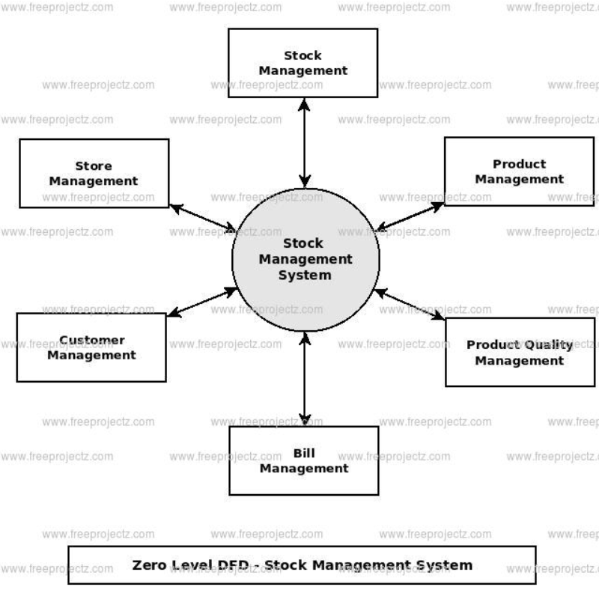**

**Zero Level DFD**

# Level 1 DFD for Stock Visualizer

The “detonated view” of the context diagram is **Stock Visualizer DFD Level 1**. Its function is to deepen the concept derive from the context diagram.

Specifically, level 1 shows the broader details of Hostel Management System DFD Level 0. This is to clarify the paths (flow) of data and its transformation from input to output.

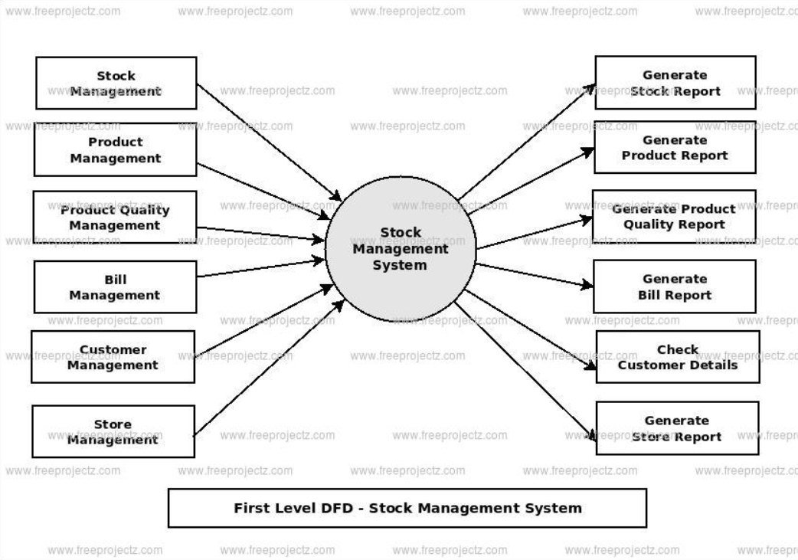

* 1. **First Level DFD**

# Unified Modelling Language (UML)

Use case diagram:

* + - **Use cases**: A use case describes a sequence of actions that providesomething of measurable value to an actor and is drawn as a horizontal ellipse.
    - **Actors**: An actor is a person, organization, or external system that plays a role in one or more interactions with your system. Actors are drawn as stick figures.
    - **Associations**: Associations between actors and use cases are indicated in use case diagram

solid lines. An association exists whenever an actor is involved with an interaction described by a use case.

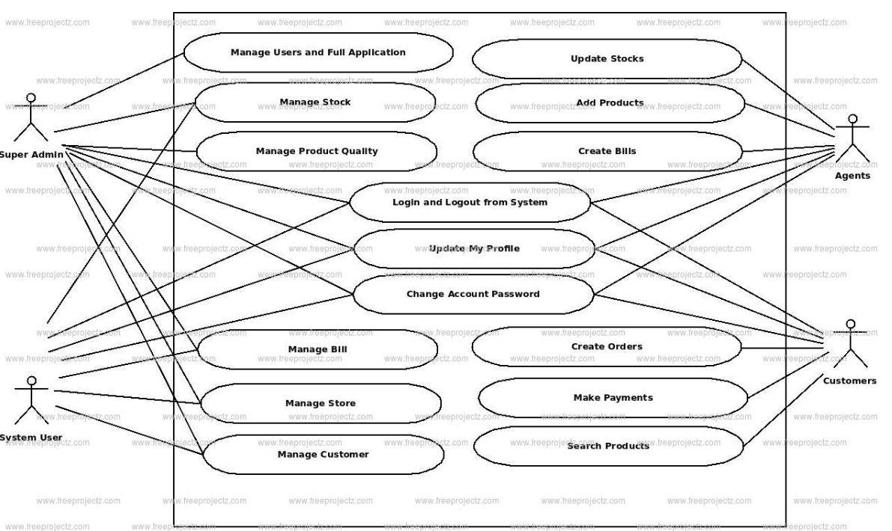

* 1. **Use Case Diagram**

# Class Diagram:

Class Diagrams describe the static structure of a system, or how it is structured rather than how it behaves. A class diagram shows the existenceof classes and their relationships in the logical view of a system.

These diagrams contain the following elements:-

* + - Classes and their structure and behaviour.
    - Association, aggregation, dependency, and inheritance.relationships.
    - Multiplicity and navigation indicators.
    - Role names.

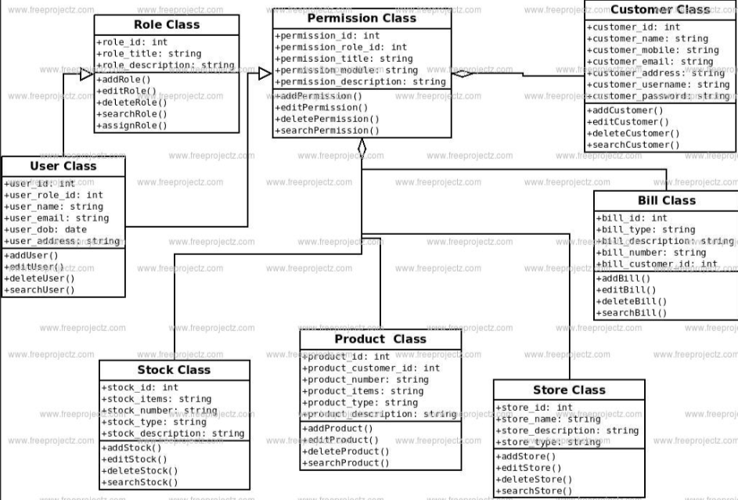

# Object Diagram: -

* 1. **Class Diagram**

Object Diagram shows a set of objects and their relationships. It is a staticsnapshot of instances. Object Diagrams describe the static structure of a system at a particular time. Whereas a class model describes all possible situations, an object model describes a particular situation.

Object diagrams contain the following elements:-

**Objects:** It represents entities. These are instances of classes. **Links:** It represents relationships between objects. These areinstances of associations.

# Sequence Diagram: -

Sequence Diagrams are interaction diagrams that detail how operations are carried out. They capture the interaction between objects in the context of a collaboration. Sequence Diagrams are time focus and they show the order of the interaction visually by using the vertical axis of the diagram to represent time what messages are sent and when.

* + 1. Sequence Diagrams describe interactions among classes. These interactions are modelled as exchanges of messages.
    2. These diagrams focus on classes and the messages they exchangeto accomplish some desired behaviour.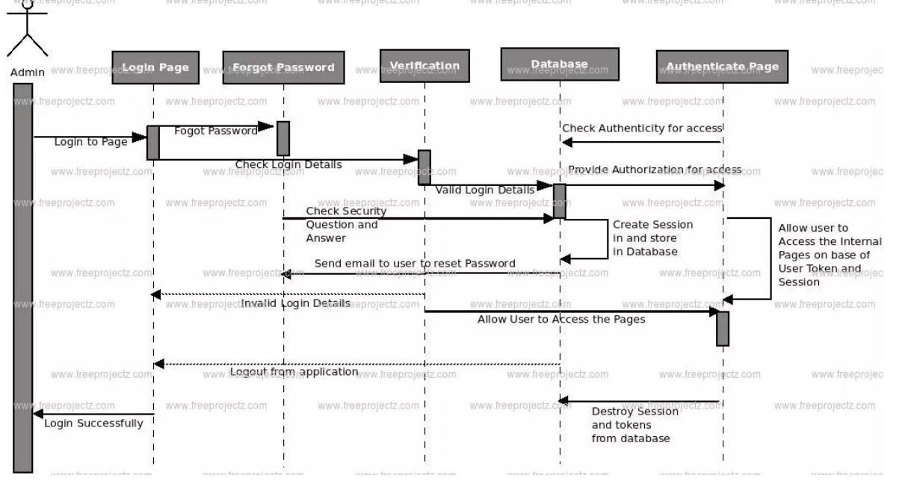
  1. **Sequence Diagram**

# Communication/Collaboration Diagram: -

A collaboration diagram, also known as a communication diagram, is an illustration of the relationships and interactions among software [objects](https://www.techtarget.com/searchapparchitecture/definition/object) in the Unified Modelling Language ([UML](https://www.techtarget.com/searchsoftwarequality/definition/Unified-Modeling-Language)). These diagrams can be used to portray the dynamic behaviour of a particular [use case](https://www.techtarget.com/searchsoftwarequality/definition/use-case) and define the role of each object.

Collaboration diagrams are created by first identifying the structural elements required to carry out the functionality of an interaction. A model is then built using the relationships between those elements. Several vendors offer software for creating and editing collaboration diagrams.

# Activity Diagram:

Activity Diagrams describe how activities are coordinated to provide a service which can be at different levels of abstraction. Typically, an event needs to be achieved by some operations, particularly where the operation is intended to achieve a number of different things that require coordination, or how the events in a single use case relate to one another, in particular, use cases where activities may overlap and require coordination. It is also suitable for modeling how a collection of use cases coordinate to represent business workflows.

Identify candidate use cases, through the examination of business workflows Identify pre- and post-conditions (the context) for use cases

Model workflows between/within use cases

Model complex workflows in operations on objects

Model in detail complex activities in a high level activity Diagram

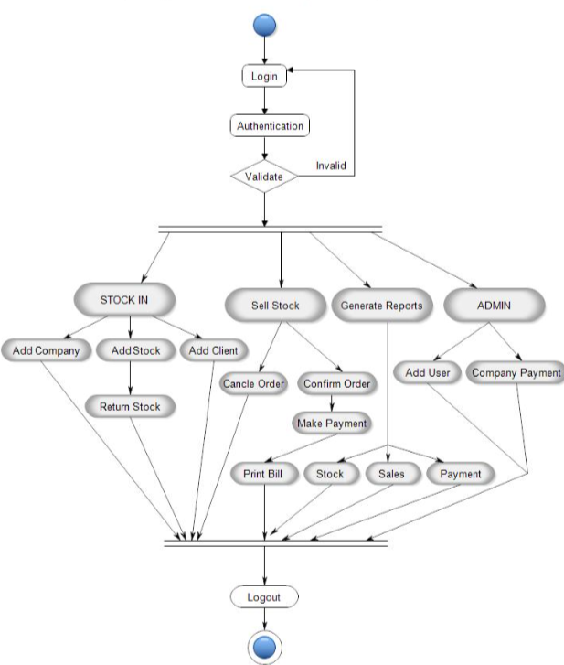

* 1. **Activity Diagram**

# State Chart Diagram: -

State chart diagram is one of the five UML diagrams used to model the dynamic nature of a system. They define different states of an object during its lifetime and these states are changed by events. State chart diagrams are useful to model the reactive systems. Reactive systems can be defined as a system that responds to external or internal events.

State chart diagram describes the flow of control from one state to another state. States are defined as a condition in which an object exists and it changes when some event is triggered. The most important purpose of State chart diagram is to model lifetime of an object from creation to termination.

State chart diagrams are also used for forward and reverse engineering of a system. However, the main purpose is to model the reactive system.

Following are the main purposes of using State chart diagrams −

* To model the dynamic aspect of a system.
* To model the life time of a reactive system.
* To describe different states of an object during its life time.

**Chapter-4**

**Conclusion And References**

# Conclusion: -

# Stock Management System Project is developed as a web-based project to meet the current stock management demands of an company or organization. The system can be accessed from anywhere with the internet. New features and modules can be incorporated into the system as per the user requirements.

# References: -

* + 1. Steven Feuerstein, Bill Pribyl ., PL/SQL Programming, O’Reilly Media, 2014
    2. Jon Duckett ., Java Script Programming, Wiley, 2014
    3. Elliotte Rusty Harold ., JAVA Networking, O’Reilly Media, 2010
    4. Rene Enriquez ., JAVA Security, Packt Publishing, 2014
    5. Bryan Basham, Kathy Sierra ., Head First EJB ,O'Reilly Media; Second edition, 2008.

**Chapter-5 Snapshots Of Project**

[](file:///D:\\New%20folder%20(2)\\OneDrive\\Desktop\\New%20folder\\index.html" \t "_self)

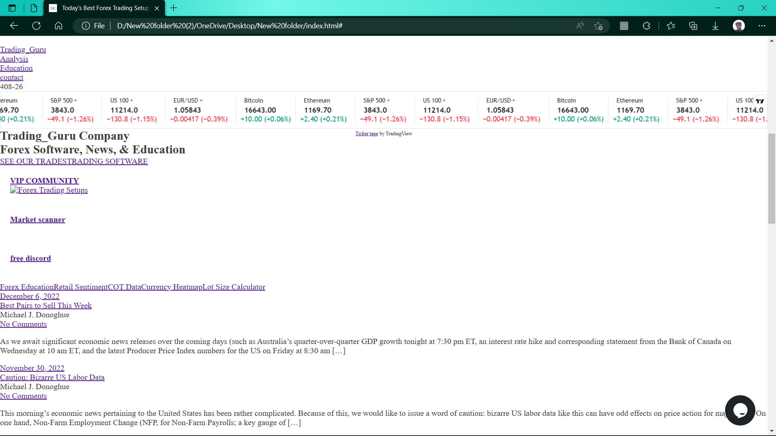

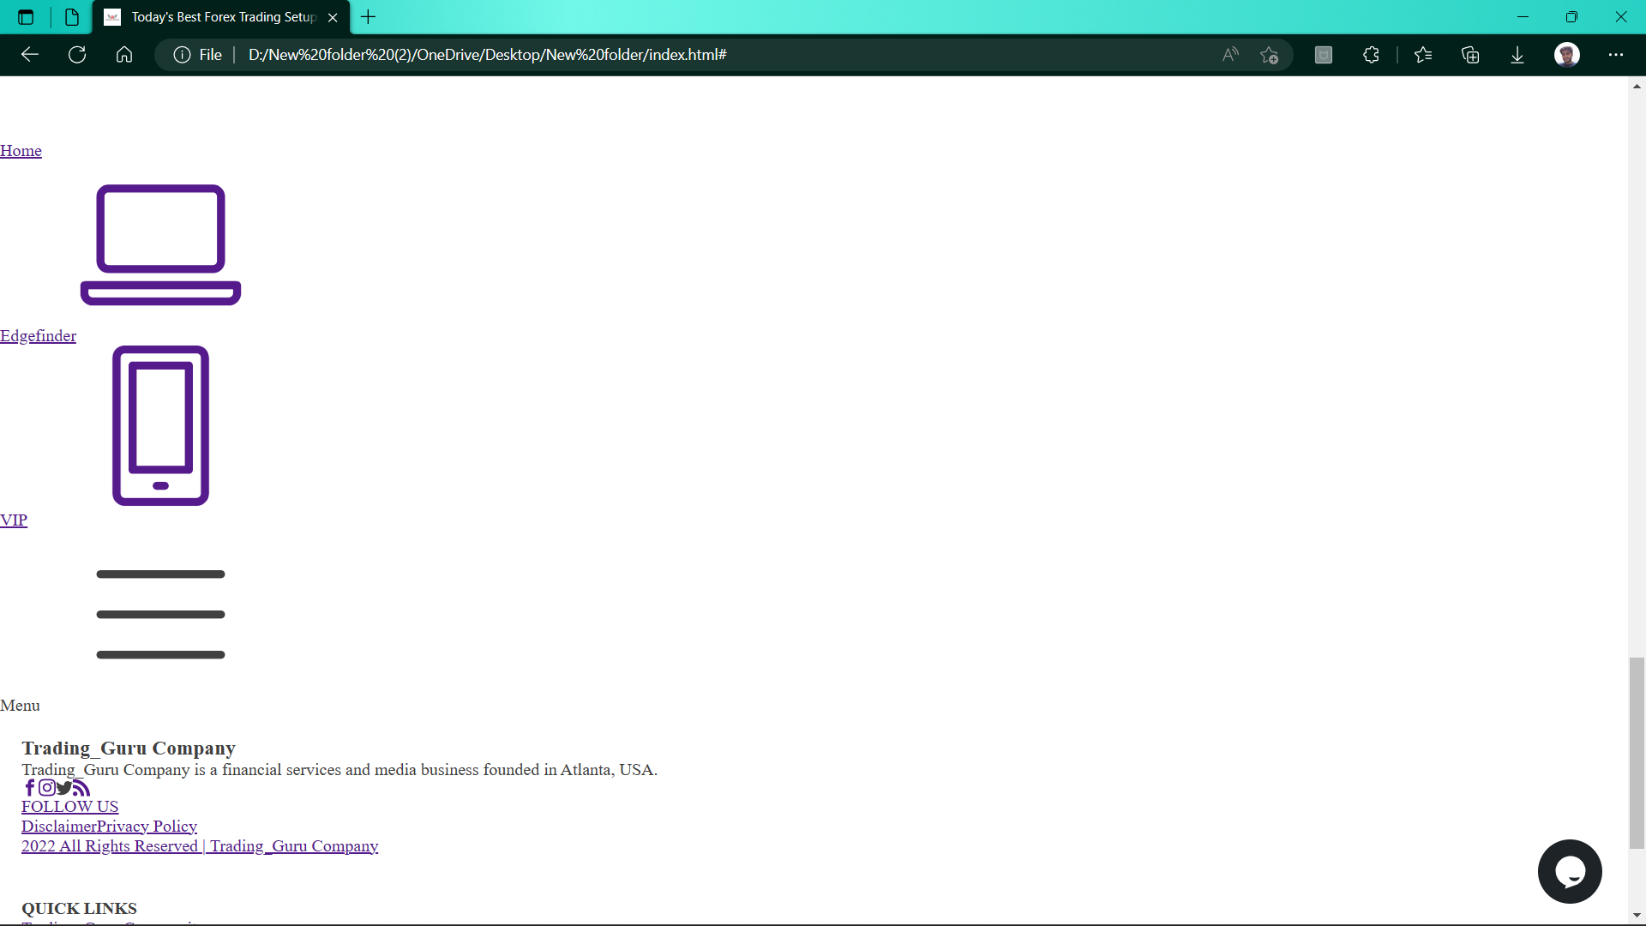

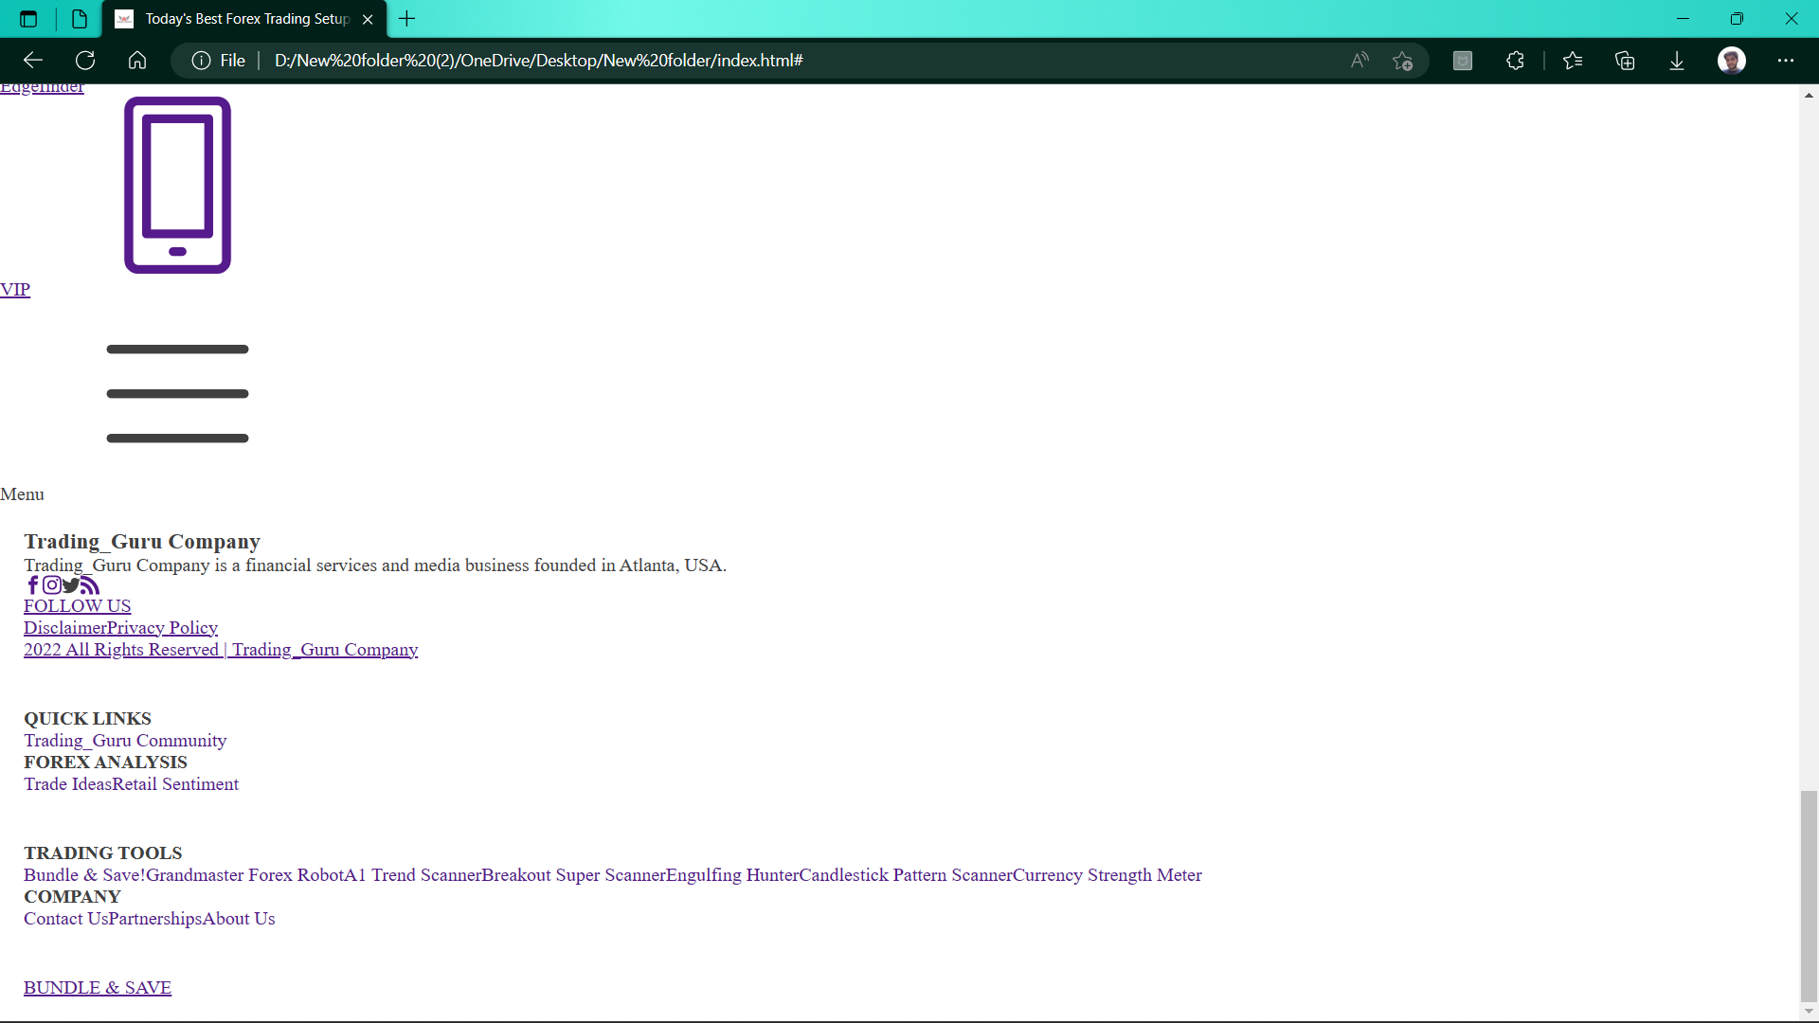

**Chapter-6 Project Code**

